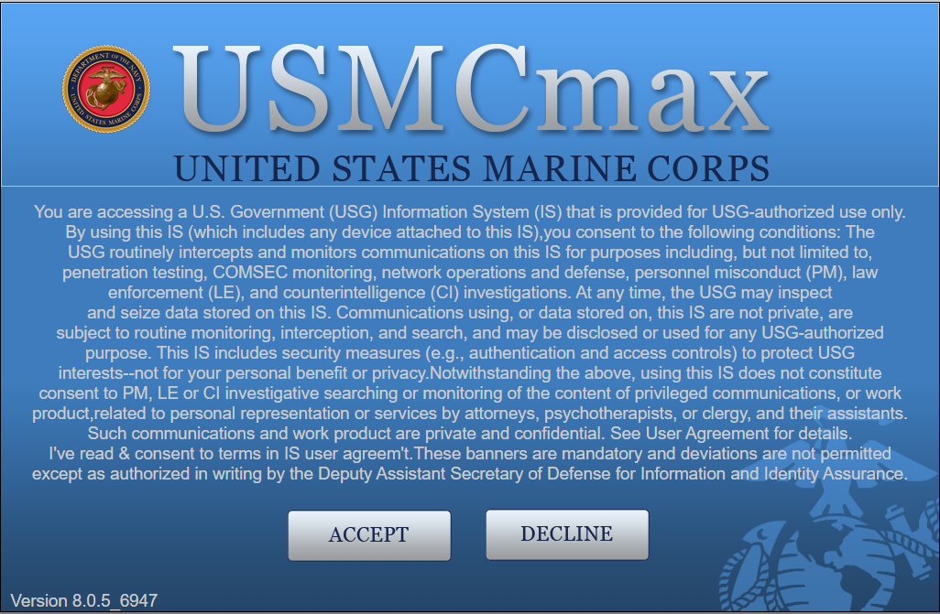

USMCmax User Guide
for Management to End User 1.0

USMCmax VERSION 7.6.4

Date | Version | Summary of Changes
FEB 2021 | 1.0 | Baseline for Release

Table of Contents
1 INTRODUCTION 1
1.1 USMCmax Modules and Applications 1
1.2 USMCmax User Guide Revision Process 1
2 MCICOM PORTAL 5
2.1 MCICOM Portal Access 5
2.2 Password Reset or Account Deactivation 6
2.3 Reporting a Problem 6
2.4 Training 7
3 ADMINISTRATION 8
4 ASSETS MODULE: LOCATION APPLICATION 9
5 ASSETS MODULE: ASSETS APPLICATION 10
6 PLANNING MODULE; JOB PLAN APPLICATION 11
7 RECURRING WORK MODULE 11
7.1 Restricted Access and Uses 12
7.2 Recurring Work Estimated Labor vs. Actual Labor 12
8 WORK ORDER TRACKING MODULE 13
8.1 Tracking Scheduled Work 13
9 SERVICE REQUEST MODULE 14
10 CHART OF ACCOUNTS 15
10.1 Restricted Access and Uses 16
11 INVENTORY AND STOREROOM MANAGEMENT 18
11.1 Recurring Work Material Projection Report Instructions 20
11.2 Add/Modify Material Reservations 21
12 MISSION EXECUTION PLAN (MEP) GUIDANCE 22
13 LONG RANGE MAINTENANCE PLAN (LRMP) GUIDANCE 23
14 QUALITY ASSURANCE GUIDE 24
14.1 Query-Based Report Sample 24
15 RUNNING STANDARD REPORTS 27
15.1 Scheduling a Report 29
APPENDIX A: Auto SAAR Guide A-1
APPENDIX B: User Overview and Application Information A-1
APPENDIX C: Person, User and Labor Records A-1
APPENDIX D: Locations A-1
APPENDIX E: Recurring Work and Workflow A-1
APPENDIX F: Work Order Tracking A-1
APPENDIX G: Service Requests A-1
APPENDIX H: Acronyms and Definitions H-1
APPENDIX I: USMCmax Installation Codes I-1

INTRODUCTION
The purpose of the USMCmax User Guide is to provide the Marine Corps USMCmax user community with a living document that serves as a consistent reference location for basic information, data definition and corporate procedural guides. The user guide will be used as a tool by all Public Works Departments (PWDs) to capture corporate policies for USMCmax usage to ensure standardization of processes across the PWDs, and to create local procedures and deviations as need be.
The user guide is designed to help familiarize users with both basic navigation in USMCmax and more detailed information for frequently used modules and their associated applications. Basic navigation instructions are given in the training guides located in the appendixes in a step-by-step format with accompanying screen shots highlighting critical steps. Module Overview – explains how the module is utilized and describes the applications that fall under the module.

USMCmax Modules and Applications
USMCmax is grouped into modules and applications. The applications that fall under a module have similar purposes. For example, applications related to purchasing are grouped together. Some applications, such as Work Order Tracking, function individually. Others, such as Precautions located within the safety application, create records designed to be used in conjunction with records created in other applications.

USMCmax User Guide Revision Process
This user guide is a living document that will continuously grow with the organization. As a tool to facilitate standardization of the community the user guide will require regular revision to incorporate additional information and to meet the needs of the organization. In order to facilitate a consistent change process, the PWDs are encouraged to provide comments and feedback to the current version of the user guide at any time utilizing the Service Change Request option located on the share point site. The appendixes are the latest versions of training guides available on the USMCmax Share Point.

Figure 1-1 – USMCmax Overview

Figure 1-1 – USMCmax User Guide – Support Modules
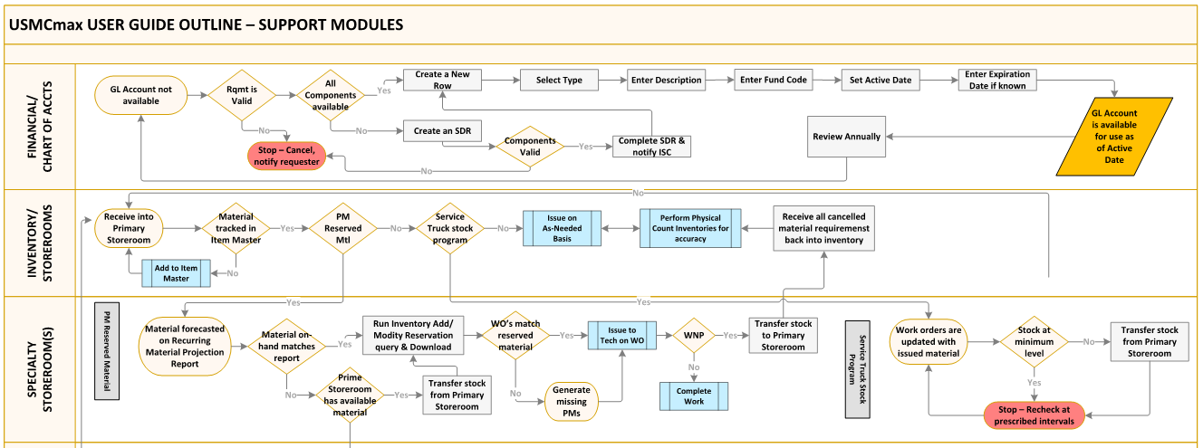

Figure 1-2 – USMCmax User Guide – Maintenance Planning and Tracking Tools
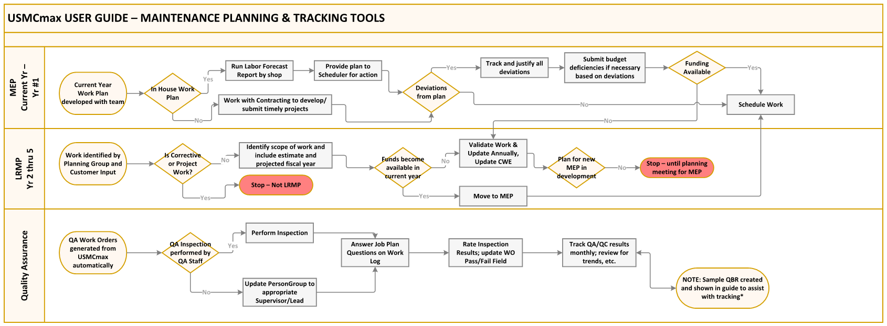
The constant flow of information and the desire to drive reliable data and metrics clearly define the need to ensure that data within USMCmax is consistently input and accurately maintained.

MCICOM PORTAL
To obtain support, MCICOM maintains a unified information system located on the portal to receive, route and manage support requests. This system is the recommended process for users to request access and support for USMCmax. The tickets are grouped into two types of requests (1) Service Desk Request (SDR) for all routine or access requests and (2) System Change Requests (SCR) used to submit requests for new work to include changes to the program and reports. System Change Requests must include an Information Technology (IT) System Change Request (ITCR) Form outlining the justification and pertinent information in order to be proposed for approval.
Examples of what USMCmax users will use the MCICOM Portal for include:
    - Request a USMCmax Account with a System Authorization Access Request (SAAR) request
    - Request a password reset or an account to be unlocked
    - Grant authorizations for additional security roles or permissions
    - Report system issues such as a loss of connection or a slowdown in operation
    - Report USMCmax operational problems or abnormal operations
    - Modify records (Work Orders, Assets, Locations, etc.) in way that exceed your authority
    - Request modifications or new GL Account options located in the Chart of Accounts

MCICOM Portal Access
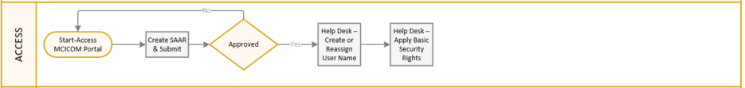
Figure 2-1 – USMCmax Access General Workflow
Section | Title | Appendix, Figure or Paragraph | Description
ACCESS | MCICOM Portal | para 2 thru 2.4 & Appendix B | MCICOM Portal access is required to access USMCmax and the features shown in this guide
 | AutoSAAR | Figure 2-1, para 2.1 & Appendixes  A & B | The purpose of the Automatic System Authorization Access Request (AutoSAAR) application is to record names, signatures, and other identifiers for validating the trustworthiness of individuals requesting access to Department of Defense (DoD) systems and information. The AutoSAAR application streamlines the SAAR approval process and is required prior to being granted access to USMCmax.
 | Create or Reassign User | Appendix C | Initial and reassigned User records are being managed by the Help Desk; updates to existing user records or security rights are done at the installation level by the ISCs.
 | Basic Security Rights | Appendix B | Unless specific security rights are identified in the user request basic security rights that are available to everyone are assigned. The local ISC may alter these rights after user is created.
Figure 2-2 – USMCmax Access General Workflow Details
To use the system, you must be able to access the MCICOM Portal. If you are not able to access the portal, please contact your PW point of contact for assistance. The MCICOM Portal website can be reached at the following URL:
https://mcicomportal.usmc.mil/Home
After reaching this screen, scroll down and select ‘CREATE SERVICE DESK REQUEST’ located above the USMCmax button and/or the Automatic System Authorization Access Request AutoSAAR button as applicable, refer to Appendix A for further instructions:
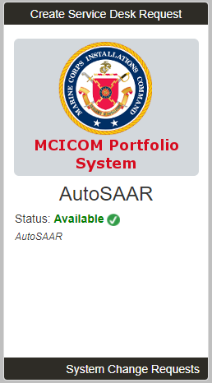
Figure 2-3 – AutoSAAR

Password Reset or Account Deactivation
IA (Information Assurance) rules require USMCmax accounts be locked if they are not used once every thirty (30) days, or after three unsuccessful login attempts. USMCmax never deletes user accounts due to financial auditability requirements, but it automatically deactivates accounts if they are not used once every forty-five (45) days.
Your local USMCmax POC or ISC should be able to reset, reactivate a blocked account or other routine administrative functions. An SDR must be submitted when local personnel cannot achieve the desired results.

Reporting a Problem
USMCmax users may experience problems such as connecting, logging in or other abnormal operations when attempting to use USMCmax. There are three general categories of problem areas that users may experience:
      - Loss of Connectivity – inability to reach USMCmax to log-in or the inability to reach other secure applications or the public internet
      - Slow Connectivity – able to log-in to USMCmax, but with unusual performance
      - Abnormal behavior - can reach USMCmax and log-in, but with unexpected actions or unusual operation

All of these problems require the submission of an SDR ticket but you should check with your local USMCmax POC or ISC prior to submitting a ticket. However, since access to USMCmax must use the MCEN network the connectivity issues are sometimes challenging to diagnose. To assist in troubleshooting, it is requested that the user submit a SDR only when you are able to reach the USMCmax log in screen but are still unable to access. Please refer other connectivity issues to the Enterprise Help Desk first.
Abnormal behavior should be reported first to your local USMCmax POC or ISC for troubleshooting prior to SDR submission. If an SDR is required ensure that you provide a detail report of the issue along with the request.
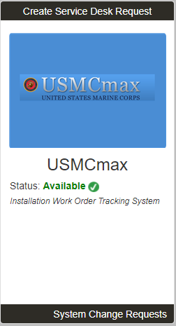
Figure 2-4 – USMCmax Production
You should receive a screen with contact information entered similar to Figure 2-1: Generic SDR Ticket Screen. If you have supplemental information/documents including screen shots, reports, or pictures, they can be attached to the ticket.
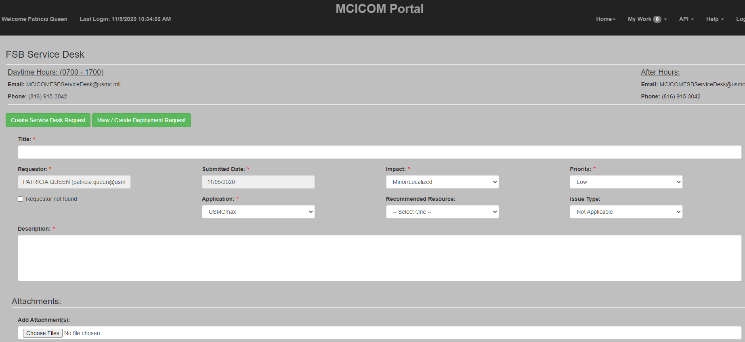
Figure 2-5 – Generic SDR Form

Training
Training guides are included in this manual and also located on the MCICOM SharePoint site along with policies. Appendix A provides additional Maximo/USMCmax training that is available within USMCmax and provided by IBMTM. The training guides that are located within this manual are located on the MCICOM SharePoint under USMCmax Home/Policies & Training References. The URL for this site is:
https://mcicom.usmc.mil/sites/GF/Maximo/SitePages/Community%20Home.aspx

ADMINISTRATION
Figure 3-1 – USMCmax Administration General Workflow

Section | Title | Appendix, Figure or Paragraph | Description
ADMINISTRATION | ISC-Create or Update Person Record | Appendix C | Specific information is required to populate Person Records (see Appendix C).
 | Responsible for Business Processes | Appendix C | The ability to execute business processes is dependent on User security rights
 | ISC-Update User Record w/Security Rights | Appendix A &  Appendix B | Ensure proper security rights are assigned to match the user’s role(s) in USMCmax
 | If work will be assigned - Add Person ID to Person Group(s) | Appendix C | A Person ID may be assigned to more than one Person Group depending on their role(s) within USMCmax. If involved in purchasing actions the Person ID will also need to be added to the Enterprise-wide Person Group (currently named MX_BUYER)
 | If Labor will be tracked within USMCmax | Appendix C | A labor record, craft and if applicable qualification record will need to be created. Only one labor record is required but may contain multiple crafts to select work assignment from.
 | If Labor will be interfaced with SLDCADA | Appendix C | Select the Interface checkbox and correct employee type is selected on Person Record. If type is incorrect the labor will not interface. If employee labor is not interfacing properly check the SLDCADA record to ensure that the DODID matches the person record.
 | Technician Sub-Process | Appendix F | To Be Completed - USMCmax Anywhere Training Guide
Figure 3-2 – USMCmax Administration General Workflow Details

ASSETS MODULE: LOCATION APPLICATION
Figure 4-1 – USMCmax Location General Workflow
Section | Title | Appendix, Figure or Paragraph | Description
ASSETS: LOCATION | Create or Import Location/Sub-Location | Appendix D | iNFADS is the authoritative source for all location records within USMCmax. Use both the DD1354 Property Transfer record and the iNFADS Property Record to populate the appropriate location fields in USMCmax
 | Apply System unless automated | Appendix D | Currently Systems are associated to locations manually. There is discussion to change this to be a managed requirement for standardization purposes.
 | Add Parent if Child or Sub-Location | Appendix D | The DD1354 will identify child locations. Sub-locations using different utilization codes or UIC's are identified on the iNFADS property record; sub-locations having different customers that utilize the same preponderant user code are not shown separately.
 | Prioritize per MDI | Appendix D | Use the MDI to set the priority of the location; this field works with the work order calculated priority field. The order of sequence for the work order calculated priority field is: (1) Use Asset priority if associated to work order or (2) Use location priority when Asset priority is blank or not assigned.
 | Associate Customer | Appendix D | Customers must be created in Company Master first and then associated to the installation prior to use
 | Update GL Account | Appendix D | MCICOM publishes approved GL Accounts in the financial guidance. USMCmax uses the Category Code and FAC Code fields on the location record for the development of GL Accounts and with customer if reimbursable.
Figure 4-2 – USMCmax Location General Workflow Details

ASSETS MODULE: ASSETS APPLICATION
Figure 5-1 – USMCmax Asset General Workflow
Section | Title | Appendix, Figure or Paragraph | Description
ASSETS: ASSET | Create or Import Assets |  | The asset inventory for new construction should be provided as part of the construction contract. Asset data may be obtained from a physical inventory.
 | Populate Uniformat and Name Plate Data |  | Accurate data is essential to an effective maintenance program. Asset information may be provided by the contractor or physical inspection.
 | Prioritize |  | Asset priorities override location priority on the work order tracking calculated priority field. Mission criticality or cost to repair/replace are important factors when determining priority of an asset.
 | Responsible Party |  | Associate Responsible Party. This identifies who is responsible for the maintenance of this property.
 | Spare Parts |  | A list of spare parts should have been provided upon installation. Critical spare parts should be available in both the Item Master and the Installation's storeroom. Association on the asset record provides critical repair information at the technician's fingertips and needs to be added to the storeroom if not currently available.
 | Associate to Master Job Plan(s) |  | If recurring maintenance is required associate the material to the job plan. This allows material to be ordered in a timely manner and reserved for the technician to pick-up.
Figure 5-2 – USMCmax Asset General Workflow Details

PLANNING MODULE; JOB PLAN APPLICATION
Figure 6-1 – USMCmax Job Plan General Workflow
Section | Title | Appendix, Figure or Paragraph | Description
JOB PLAN | Create or Import Job Plan |  | Utilizing a Master Job Plan is the primary source for creating recurring work requirements within USMCmax. If a Master Job Plan does not exist, a job plan will be created.
 | Identify Asset(s) |  | Identify the assets that the new job plan will be associated to.
 | Modify Job Plan |  | Modify for any local adjusters such as material, safety, etc.
 | Determine Method of Accomplishment |  | Determine if work will be done in-house or via contract based on labor estimates with PM Manager and/or team.
Figure 6-2 – USMCmax Job Plan General Workflow Details

RECURRING WORK MODULE
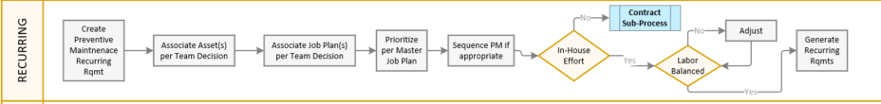
Figure 7-1 – USMCmax Job Plan General Workflow
Section | Title | Appendix, Figure or Paragraph | Description
RECURRING WORK | Create PM Recurring Requirement | Appendix E | Create new recurring requirement per team discussion
 | Associate Asset(s) | Appendix E | Associate asset(s) that apply to new PM
 | Associate Job Plan(s) | Appendix E | Associate Job Plan(s) as discussed with team
 | Prioritize | Appendix E | Prioritize based on Master Job Plan
 | Sequence if applicable | Appendix E | Sequencing recurring work is the most efficient method of PM generation.
 | In-House Effort | Appendix E | If no, proceed to contracting sub-process. If yes, proceed to labor balancing
 | Labor Balanced | Appendix E | If no, adjust PM's until labor is balanced
 | Generate Requirements | Appendix E | Generate Recurring requirements on a set schedule that works with the staging of reserved material.
Figure 7-2 – USMCmax Recurring Work General Workflow Details

Restricted Access and Uses
Restricted access is recommended to USMCmax roles that impact workload scheduling, labor balancing and material reservations. Some access may be required to create new recurring work but may restrict ability to modify existing, generate or place in approved status recurring work.

Recurring Work Estimated Labor vs. Actual Labor
USMCmax has reports available to compare estimated labor versus actual labor used on recurring work. Performing a quick comparison will identify potential issues with the recurring work estimates; large labor discrepancies may be due to a number of factors and should be investigated prior to making any changes to your program.

The following example report that is run in the Recurring Module called Recurring Work Estimates vs Actuals report works well when downloaded into excel and adding a variance percentage to the comparison:

WO # | Description | Person Grp | Route | Est.Dur. | # Routes | Est.hrs | Act. Hrs. | Comp | JP #
9125626 | T1 - BW (R1) - BI-WEEKLY (E) - GENERATOR (CHECK JOB PLAN) | YUELEC |  | 1 | 0 | 1 | 0.5 | 1 | 1032 | 50%
9125640 | T1 - BW (R1) - BI-WEEKLY (E) - GENERATOR (CHECK JOB PLAN) | YUELEC |  | 1 | 0 | 1 | 0 | 1 | 1032 | 0%
9126064 | T1 - (R1) - BI-WEEKLY (E) - GENERATOR (CHECK JOB PLAN) | YUELEC |  | 1 | 0 | 1 | 2 | 1 | 1032 | 200%
9126078 | T1 - (R1) - BI-WEEKLY (E) - GENERATOR (CHECK JOB PLAN) | YUELEC |  | 1 | 0 | 1 | 0 | 1 | 1032 | 0%
9126380 | T1 - BW (R1) - BI-WEEKLY (E) - GENERATOR (CHECK JOB PLAN) | YUELEC |  | 1 | 0 | 1 | 0.5 | 1 | 1032 | 50%
9126394 | T1 - BW (R1) - BI-WEEKLY (E) - GENERATOR (CHECK JOB PLAN) | YUELEC |  | 1 | 0 | 1 | 0 | 1 | 1032 | 0%
9126696 | T1 - (R1) - BI-WEEKLY (E) - GENERATOR (CHECK JOB PLAN) | YUELEC |  | 1 | 0 | 1 | 1 | 1 | 1032 | 100%
9126710 | T1 - (R1) - BI-WEEKLY (E) - GENERATOR (CHECK JOB PLAN) | YUELEC |  | 1 | 0 | 1 | 0 | 1 | 1032 | 0%
9127012 | T1 - (R1) - BI-WEEKLY (E) - GENERATOR (CHECK JOB PLAN) | YUELEC |  | 1 | 0 | 1 | 2 | 1 | 1032 | 200%
9127026 | T1 - (R1) - BI-WEEKLY (E) - GENERATOR (CHECK JOB PLAN) | YUELEC |  | 1 | 0 | 1 | 0 |  | 1032 | 0%
9127406 | T1 - (R1) - BI-WEEKLY (E) - GENERATOR (CHECK JOB PLAN) | YUELEC |  | 1 | 0 | 1 | 1 | 1 | 1032 | 100%
9127420 | T1 - (R1) - BI-WEEKLY (E) - GENERATOR (CHECK JOB PLAN) | YUELEC |  | 1 | 0 | 1 | 0 | 1 | 1032 | 0%
9127722 | T1 - (R2) - BI-WEEKLY (E) - GENERATOR (CHECK JOB PLAN) | YUELEC |  | 1 | 0 | 1 | 0.5 | 1 | 1032 | 50%
Figure 7.2-1 – Recurring Work Estimates vs Actuals Report Example

WORK ORDER TRACKING MODULE
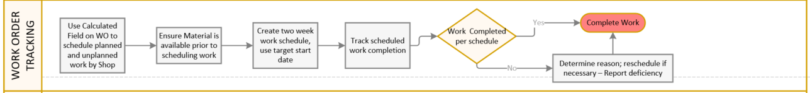
Figure 8-1 – USMCmax Work Order Tracking General Workflow
Section | Title | Appendix, Figure or Paragraph | Description
WORK ORDER TRACKING | Schedule Work | Appendix F | Use the Work Order Calculated Priority field to assist in scheduling recurring work with corrective work.
 | Validate Material is Available | Appendix F | Prior to issuing work to the technicians all material must be available
 | Create two-week work schedule | Appendix F | Modify for any local adjusters such as material, safety, etc.
 | Determine method of accomplishment | Appendix F | Determine if work will be done in-house or via contract based on labor estimates with PM Manager and/or team
 | Track Scheduled Work |  | Use Work Order Tracking report or other method to ensure work is accomplished on time per schedule. Target start date is used on the Work Order Tracking report and may be used for either in-house or contracted effort.
 | If Work Not Complete |  | Determine reason for incomplete work; reschedule if necessary (use either overtime or contract/credit card to accomplish so remaining scheduled work is not impacted). Report deficiency to QA Manager with justification to include resolution plan.
Figure 8-2 – USMCmax Work Order Tracking General Workflow Details

Tracking Scheduled Work
The USMCmax Scheduled Work Order report runs off of the current query and provides work information based on the Target Start Date. As shown below the estimated and actual labor along with work order status is also provided so that any labor effort currently expended (if approved) can be seen. Use the Advanced Tab to set the Target Start Date parameters prior to running this report. The report works for any Work Group that populates the Target Start Date.

Another example of use includes the contracting division. They can utilize this report to assign workload actions to their project managers to ensure the projects are prepared and ready to send to contracting on or before the MEP required date, etc.
NOTE: There are many reports available in USMCmax that will provide timeliness, execution, costs, etc. to assist with determining program effectiveness. This report is only one example.
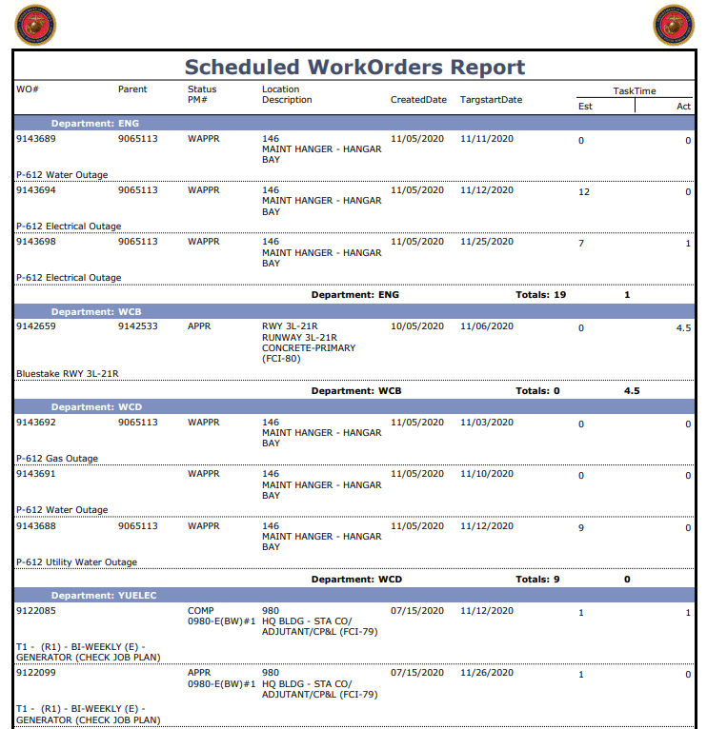
Figure 8.1-1 – Example of the Scheduled Work Order Report

SERVICE REQUEST MODULE
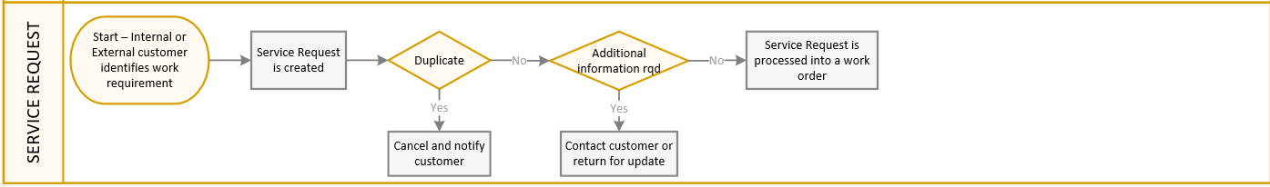
Figure 9-1 – USMCmax Service Request General Workflow

Section | Title | Appendix, Figure or Paragraph | Description
SERVICE REQUEST | Identification of Work | Appendix G | Internal or External Customers identify work requirements being requested
 | Service Request is created | Appendix G | Customer creates Service Request
 | Validation by Customer Service Representative | Appendix G | Customer Service Representative (CSR) validates work and information contained on service request
 | Duplication | Appendix G | CSR cancels request and contacts customer
 | Additional information required | Appendix G | CSR contacts customer and updates service request
 | Process Service Request | Appendix G | CSR converts service request to work order for processing
Figure 9-2 – USMCmax Service Request General Workflow Details

CHART OF ACCOUNTS
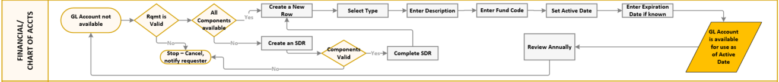
Figure 10-1 – USMCmax Chart of Accounts General Workflow

Section | Title | Appendix, Figure or Paragraph | Description
CHART OF ACCOUNTS | GL Account Error |  | GL Account not available for use in USMCmax
 | Requirement is valid |  | Validate GL Account and work are both valid requirements
 | GL Account components available |  | If yes, create new row and fill-in fields appropriately. If not, create SDR. Appendix C touches building a GL Account string and GL Account components when discussing labor entries.
 | SDR |  | Submit SDR identifying missing components, titles, etc. with justification
 | Help Desk completes SDR |  | Creates components after validation and notifies ISC
 | Create new row |  | ISC creates new row and fills in fields appropriately
 | Perform Annual Review & Update |  | Responsible parties review existing active GL Accounts annually; update as needed
Figure 10-2 – USMCmax Service Request General Workflow Details

Restricted Access and Uses
Restricted access is recommended to USMCmax roles that include a strong understanding of financial components and their proper uses. This module sets up the general ledger (GL) accounts that are used to track all aspects of work within USMCmax. The user creates accounts and resource codes to correspond with accounts that are used in the Marine Corps external accounting system, the Standard Accounting, Budgeting, and Reporting System (SABRS). It is also recommended that the installation’s Chart of Accounts be reviewed annually by the local Comptroller Office to ensure local adherence to active GL accounts necessary for day-to-day maintenance and support.

The Chart of Accounts is accessed from the Financial Module and is visible to user’s that have the proper security rights:

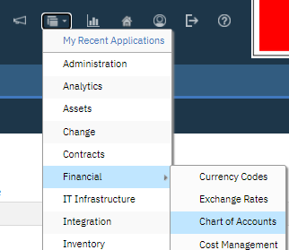
Figure 10.1–1 – Chart of Accounts access screenshot

If all of the GL Account components have been validated and are available for selection the user may create a line of accounting by selecting New Row:

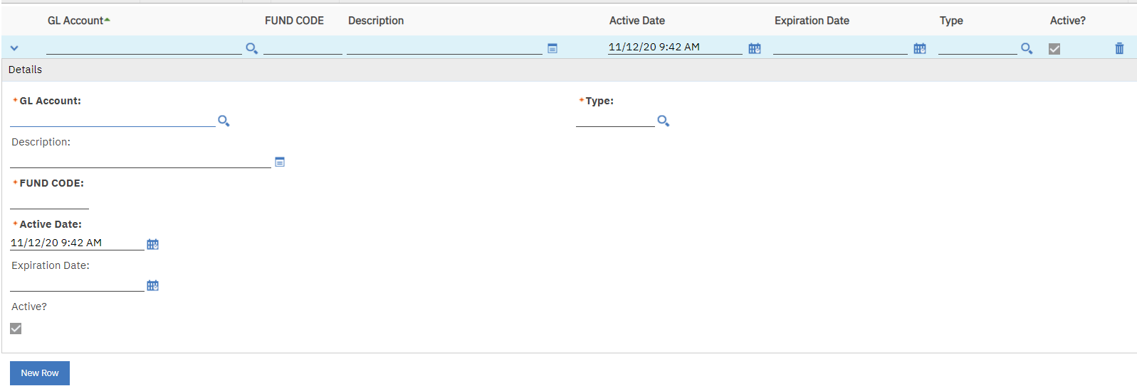
Figure 10.1–2 – Chart of Accounts New Row screenshot
Creating a new GL Account: The user will build a GL Account string of accounting by selecting each component individually as required. If a portion of the component is unavailable to be selected the user must stop and submit an SDR to the Help Desk to have the components added for use. The user is required to identify the Type that corresponds to various functions within USMCmax such as; (1) BSM1 types can be used throughout USMCmax but (2) Type PURC (Purchase) accounts cannot be used on work orders they are only to be used for purchase type actions, etc.

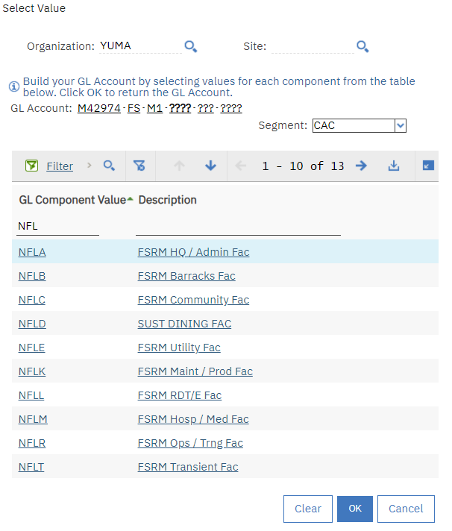
Figure 10.1–3 – Chart of Accounts component screenshot

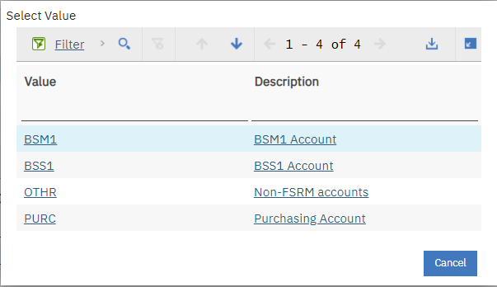
Figure 10.1–4 – Chart of Accounts Type screenshot

Example of the description field in an SDR that is requesting a new GL Account be added; ensure that a justification for the addition is included with the request:

Example of Description Field:
CIWEST HAS REQUESTED SPECIAL INTEREST CODE FOR COVID 19 RELATED PURCHASES BE CHANGED TO ALIGN WITH CARES ACT LEGISLATION.
UPDATE GL ACCOUNT INFO AS FOLLOWS:
WCI: M42974
BEA: LP
BESA: LP
CAC: NFMS
SPECIAL INTEREST CODE (SIC): V50 *Note 1
FUNDS CODE: AY *Note 2
*Note 1: Update Title to read – “COVID BSS1 Baseline” after creation if not done by Help Desk
*Note 2: The only Funds Code authorized for BSM1 is AE (Financial guidance sent out by MCICOM will provide you with valid components and associated Fund Codes)

INVENTORY AND STOREROOM MANAGEMENT
Figure 12-1 – USMCmax Inventory and Storeroom Mgmt General Workflow
Section | Title | Appendix, Figure or Paragraph | Description
INVENTORY/STOREROOMS | Receive into Primary Storeroom |  | All material/items are managed thru the primary storeroom and then transferred to any specialty storeroom(s) as appropriate. This practice reduces physical count and reorder errors.
 | Material tracked in Item Master |  | Item Master is the source of all storeroom material; if material is not currently in Item Master then it must be created.
 | PM Reserved Material |  | Recurring Work that includes material and is forecasted will result in reserved material. If yes, proceed to Specialty Storeroom(s).
 | Service Truck stock program |  | If yes, proceed to Specialty Storeroom(s).
 | Issue on As-Needed basis |  | Issue non-specialty storeroom material as needed from Primary Storeroom
 | Perform Physical Count |  | Perform physical count inventories/audits to ensure item availability is accurate.
 | Cancelled material |  | Receive all cancelled material/items that have been issued out back into the primary storeroom
Figure 12-2 – USMCmax Inventory and Storeroom Mgmt General Workflow Details

Section | Title | Appendix, Figure or Paragraph | Description
PM RESERVED MATERIAL
Specialty Storeroom(s) | Material forecasted | Appendix G | Material that is associated to recurring work on the job plan and the PM has been forecasted is available to be seen on the Material Projection Report.
 | Staged Material matches report |  | Material that is on hand in this storeroom matches the Material Projection Report quantities required. If not, transfer from Prime Storeroom.
 | Add/Modify Reservation |  | From the Inventory Module, select Add/Modify Reservation and download results. Every generated PM that contains material requirements are identified on this download. Filter appropriately to ensure that all required PMs have been generated and that the material on hand in this storeroom has an associated work order.
 |  |  | If there are missing work orders return to recurring module and ensure that all work has been generated.
 | Issue to Technician |  | Issue staged material to technician. Ensure material is associated on work order by selecting Reserved Material on the material tab.
 | Work Not Performed (WNP) |  | If all or a portion of the work was not performed ensure that the material is returned to this storeroom and then transferred back to the primary storeroom.
 |  |  | This will ensure that this storeroom only holds material that is associated to open work. When all the work orders have been either completed or WNP'd then all of the material should have been issued out. Separating the staging area by month or week will assist in tracking this material.
 | Service Truck Stock Program
 | Service Truck has bins that hold typical material |  | Service Truck(s) are set up to contain material bins that hold typically used material for ease of access. Material is transferred from the primary storeroom to these bins for issuing to technicians.
 | Work Orders Updated |  | Material that is issued in the field from the service truck(s) is associated to the work orders by selecting the appropriate storeroom on the material tab.
 | Stock checked for depletion |  | Each evening the service truck(s) need to be checked for depleted stock levels.
 | Transfer stock |  | Refill service truck bin(s) by transferring material from the prime storeroom to the Service Truck storeroom. This should be done by close of business so that the truck(s) are available first thing in the morning for work.
Figure 12-3 – USMCmax Specialty Storeroom Mgmt General Workflow Details

Recurring Work Material Projection Report Instructions
This report includes a route related option - Multiple Quantity and Cost by Route Stops. The Multiple Quantity and Cost by Route Stops option allows you to use one of two business concepts when creating your job plans: (See report examples for Item #5W512)
- Y - Job Plan material is equal to one job plan action (one-to-one ratio) – so if you have a route associate the quantity of each material item line will be multiplied by the number of route stops. (Job Plan Use Example – your job plan calls for 1 battery to be replaced during the PM Inspection and that same battery is used at 19 other locations; your job plan has a route for the 19 locations and your material is calculated to equal 19 batteries)
(Item #5W512 with Multiple Quantity and Cost by Route Stops = Y is equal to 248)

- N – Job Plan material is equal to whole job plan such as a whole building but the labor is equal to a single action. In this case; the job plan has 19 route stops but your material for that building is the total on the item line with no multiplier applied for the route stops. (Example – 19 Air Handler units at a building may have different filter sizes but all use the same job plan and labor estimate; the labor is calculated on the forecast report using the number of units in the route – but – the material is designed for the whole building as a total since there are different filter sizes).
(Item #5W512 with Multiple Quantity and Cost by Route Stops = N is equal to 29)
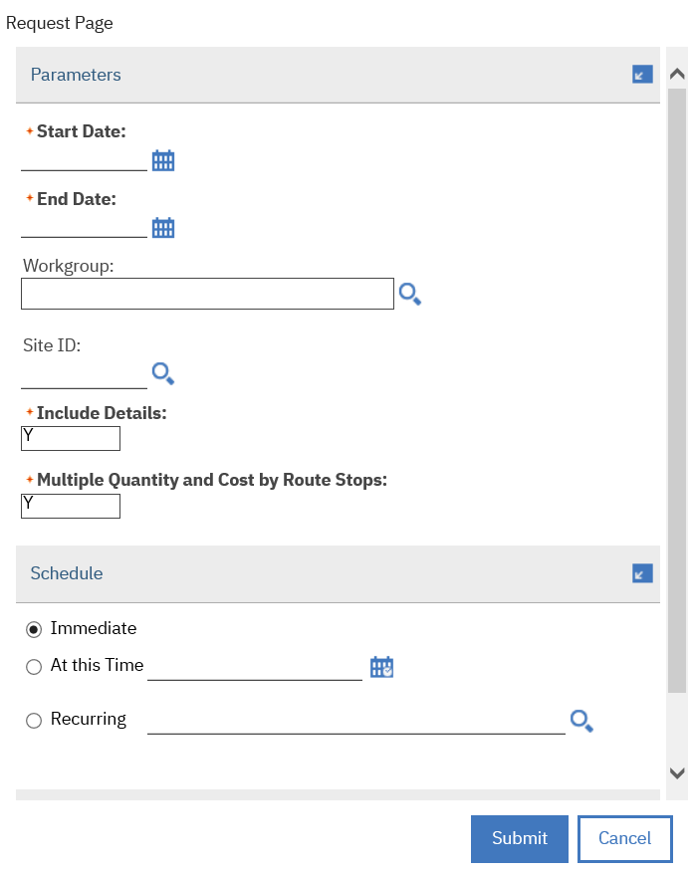
Figure 12.1-1 – Recurring Work Material Projection Report Option
Sample Report – Tabs 1 and 2:
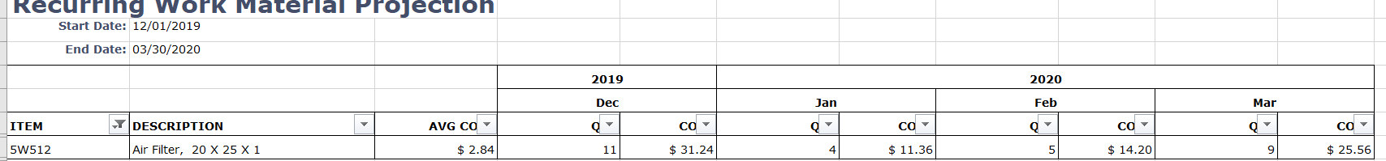
Figure 12.1-2 - Tab 1 (Filtered to Item = 5W512 with Option = N - Total Rq’d = 29)

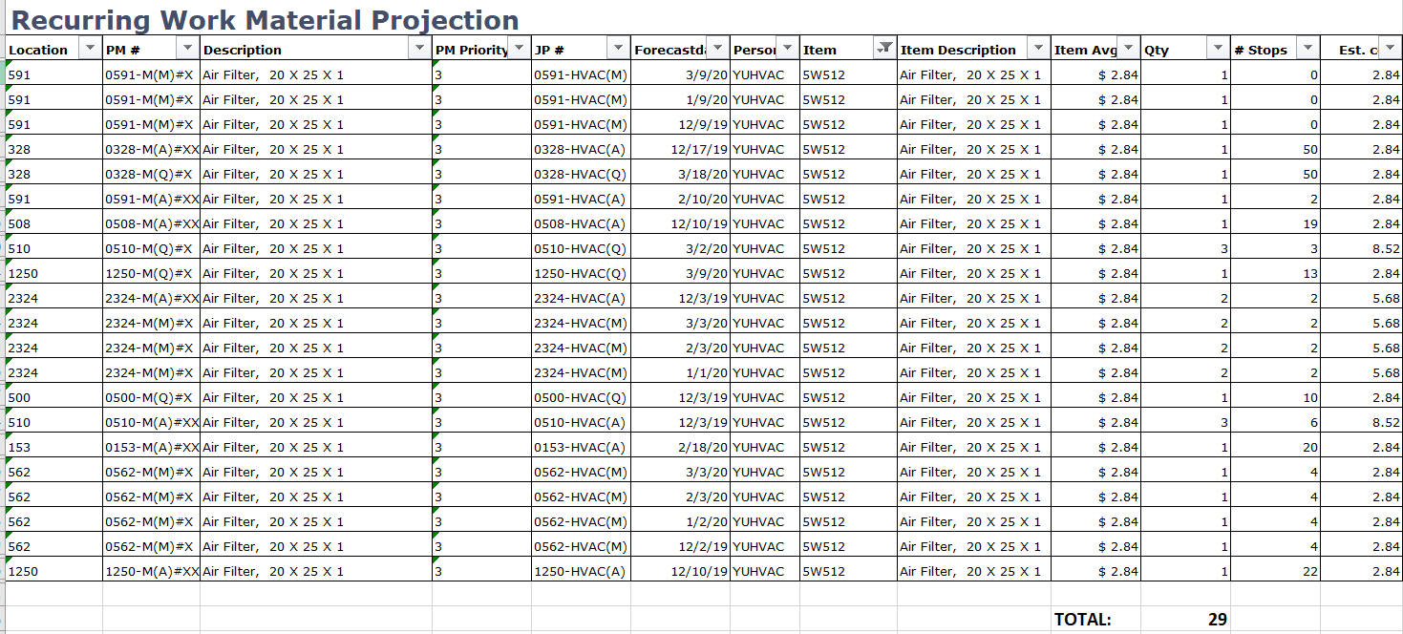
Figure 12.1-3 - Tab 2 Audit Tab (Total Rq’d = 29 with detail information; i.e. locations, PM, Forecasted Date, etc.)

Add/Modify Material Reservations
Using the Inventory Module select the appropriate storeroom in order to get a listing of the reserved material with associated work order numbers.
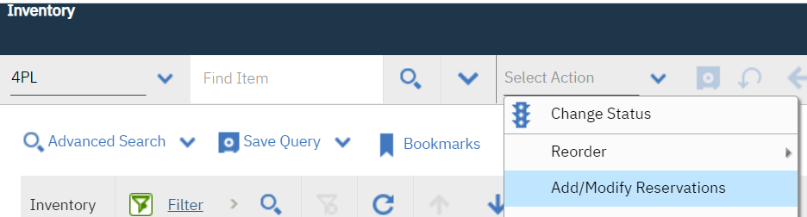
Figure 12.2-1 – USMCmax Inventory Add/Modify Screenshot

Slide the bar over to the right in order to see the download button option; select this and save the excel spreadsheet. From that spreadsheet use the filtering options to select the work order numbers along with reserved item quantities that need to be staged for pickup.

NOTE: If there are material requirement changes made to a PM that has been generated the Reserved Quantity shown below may be updated to reflect the proper number of items or be removed so that staging is accurate.
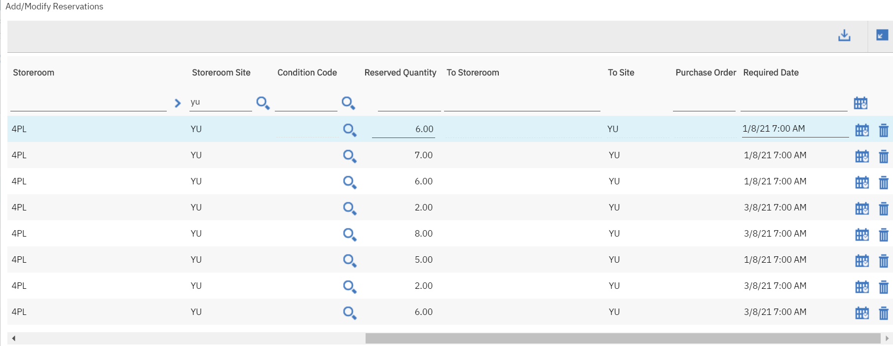

Figure 12.2-2 – Add/Modify Download Button and Slide

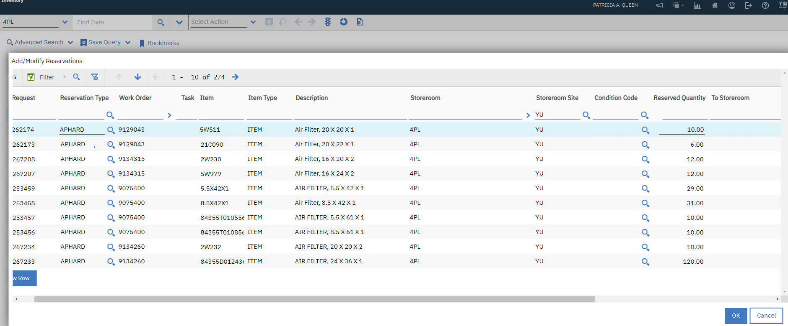
Figure 12.2-3 - Add/Modify Reservations initial view

MISSION EXECUTION PLAN (MEP) GUIDANCE
Figure 13-1 – Mission Execution Plan (MEP) General Workflow
Section | Title | Appendix, Figure or Paragraph | Description
MISSION EXECUTION PLAN (MEP) | Develop Current Year Work Plan |  | Set-up a team of qualified individuals to review both in-house and contracted work plans. There may be more than one team involved with this effort.
 | Contract Work Plan |  | Ensure review team includes representatives from budget and Contracting to develop target submission dates, project groupings, etc. to maximize efficiency of contract options.
 | In-House Work Plan |  | Run Labor Forecast report by shop prior to start of new fiscal year. Ensure labor is balanced to meet expectations and discuss with team. When approved, provide copy to scheduler for implementation.
 | Deviations from work plan(s) | Para 8.1 | Track and justify any deviation from approved work plans. Provide justification and resolution plan to QA team(s). Ensure resolution plan does not adversely affect on-going work schedules.
 | Submit Budget Deficiency if necessary |  | Create mid-year budget deficiency based on work plan deviations if funding is not available to complete all scheduled/planned work.
Figure 13-2 – MEP General Workflow Details

LONG RANGE MAINTENANCE PLAN (LRMP) GUIDANCE
Figure 14-1 – Long Range Maintenance Plan General Workflow
Section | Title | Appendix, Figure or Paragraph | Description
LONG RANGE MAINTENANCE PLAN (LRMP) | Identify LRMP Work in USMCmax |  | LRMP by definition is work identified under inspections conducted under a form of Backlog Maintenance and Repair (BMAR) or customer submitted work. It does not include typical corrective or project related work.
 | Create Scope of Work |  | Create scope of work (SOW), current working estimate (CWE), projected year to be accomplished, etc.
 | Funding Available |  | Current year funds become available and the work has a high enough priority for the review team to include in MEP
 | Funding Unavailable |  | Current year funds are not available or priority is too low to accomplish in MEP - Validate the work is still required, SOW is accurate and update CWE annually. This will allow proper evaluation by team when determining to include/not include in MEP.
 | Validation of SOW |  | SOW and CWE Update notes are required to be placed in the USMCmax Work Log. Any work not validated within 365 days should be removed from USMCmax so that only valid work remains in LRMP.
Figure 14-2 – LRMP General Workflow Details

QUALITY ASSURANCE GUIDE
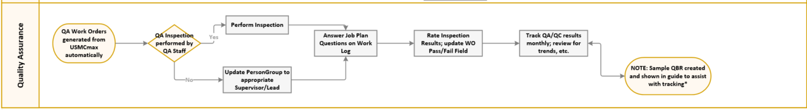
Figure 15-1 – Quality Assurance Guide General Workflow
Section | Title | Appendix, Figure or Paragraph | Description
QUALITY ASSURANCE GUIDE | QA/QC Work Orders Generated |  | QA/QC work orders are generated automatically from USMCmax to meet the inspection percentages defined in the attached guidance
 | Inspectors |  | Inspections will be conducted by qualified personnel. Inspectors may be associated to the QA team, shop supervisor/lead personnel, Contracting Officer Representatives (CORs) or Performance Assurance Evaluators (PARs).
 | Provide inspection results |  | In USMCmax, answer questions associated to the job plan on the work order in USMCmax. Report findings on Work Log tab and select evaluation results on work order Pass/Fail field.
 | Track Results |  | QA Manager is responsible to track monthly results of inspections regardless of who performed the inspections. A sample QBR has been provided to assist with this tracking.
Figure 15-2 – Quality Assurance General Workflow Details

Query-Based Report Sample
Create a query-based report (QBR) to assist in tracking the QA/QC results. Screenshots are provided below to assist with this creation.
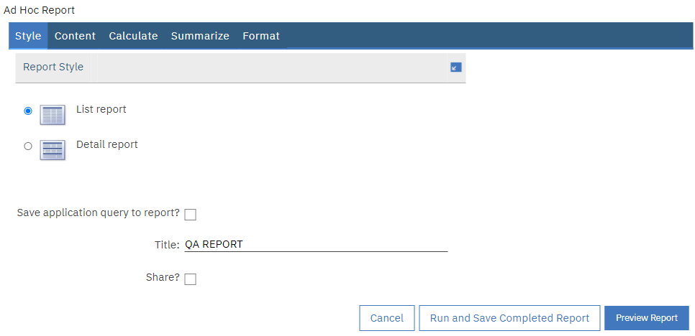
Figure 15.1-1 – Creating a Query Based Report (QBR) – Step One
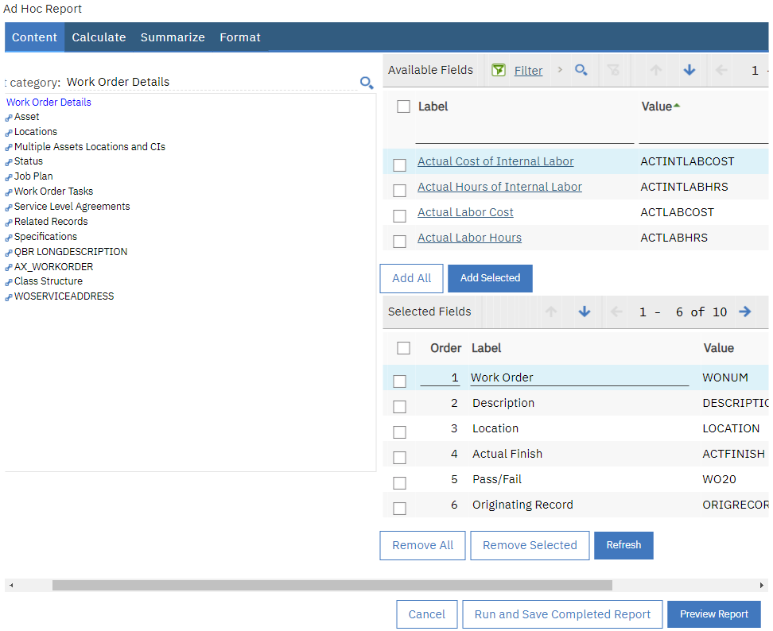
Figure 15.1-2 – Creating a Query Based Report (QBR) – Step Two

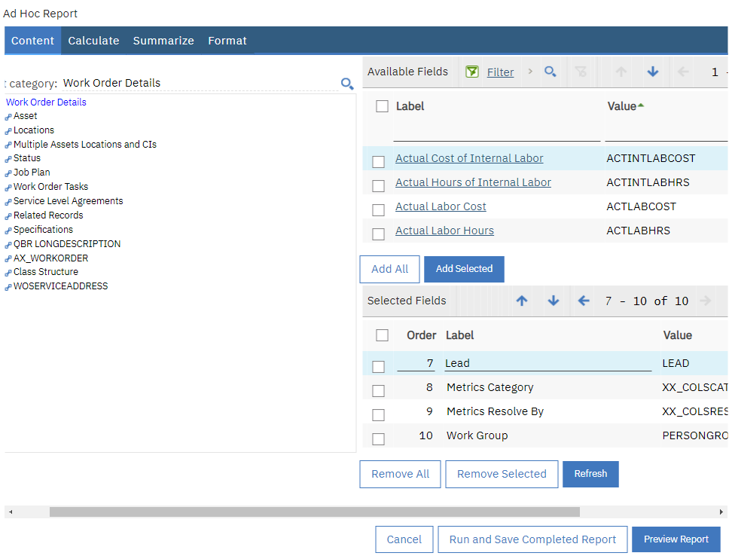
Figure 15.1-3 – Creating a Query Based Report (QBR) – Step Three
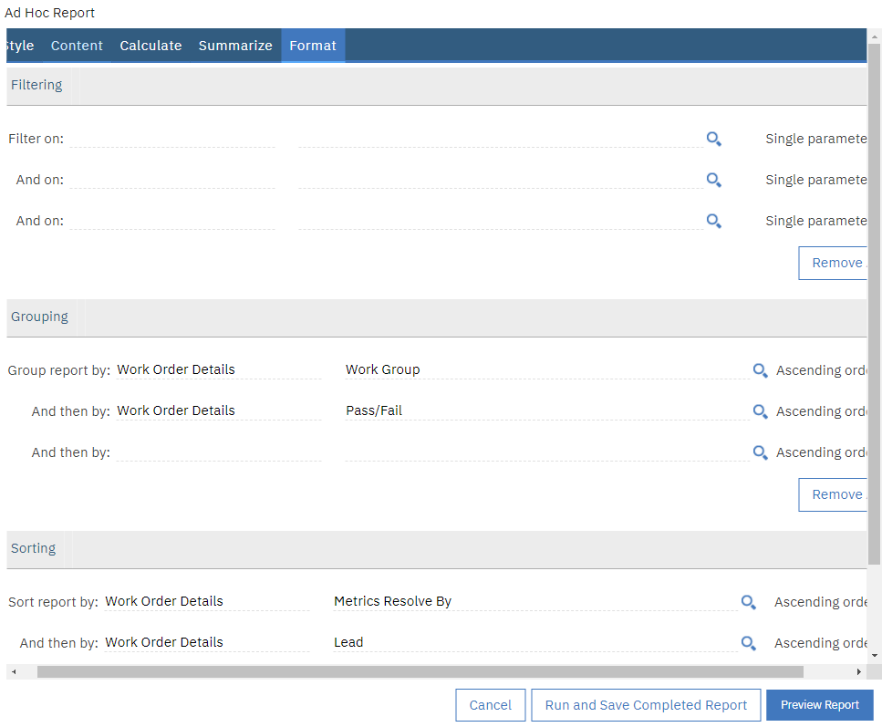
Figure 15.1-4 – Creating a Query Based Report (QBR) – Step Four

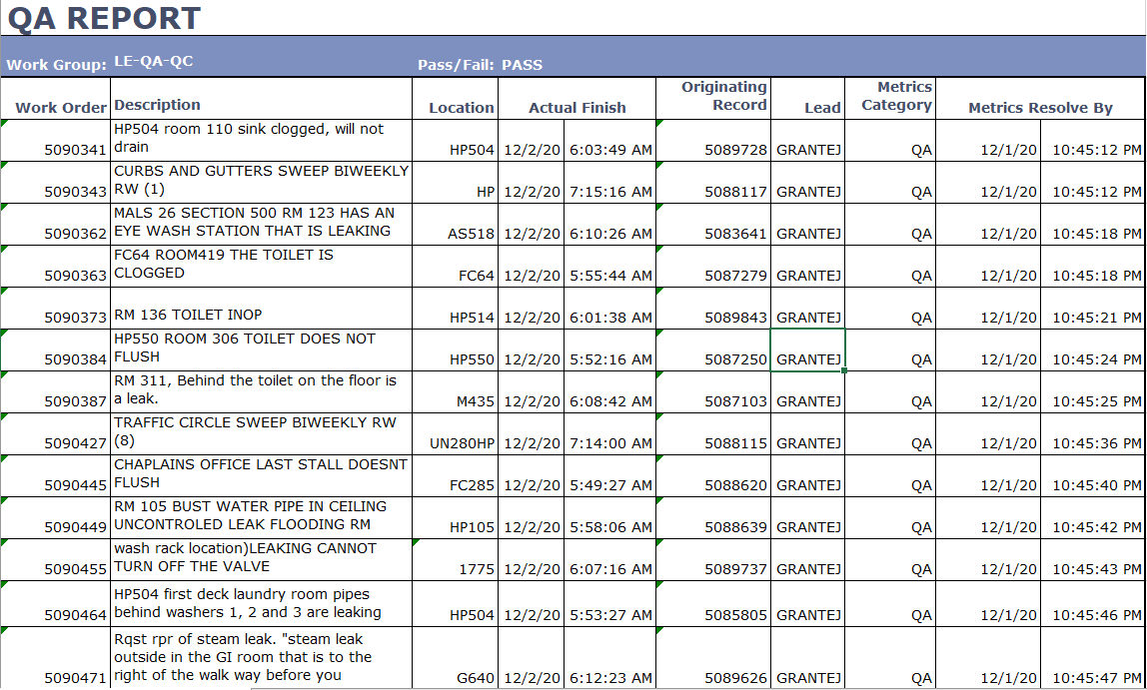
Figure 15.1-5 – Creating a Query Based Report (QBR) – Report Result

RUNNING STANDARD REPORTS
This section reviews basic reporting functionality related to accessing reports. Reports can be assessed immediately or based on a schedule. In addition, there may be parameters that the user can select to limit the report such as a parameter indicating that data should only be pulled from one site. This example will use Work Order Tracking to illustrate these points.

- Step 1: Access the Work Order Tracking application by selection is from the ‘Go To’ or Favorites Menu.

- Step 2: The Work Order Details report will be accessed here. Because this report tends to display a great deal of information, the number of Work Orders that can be displayed with this report has been limited. If requests are too large, the user will receive a System Message because a maximum of 200 Work Order records can be accessed at a time.

- Step 3: Search for the Work Order Record that you wish to run the report on.

- Step 4: Select Run Reports from the Select Action menu.
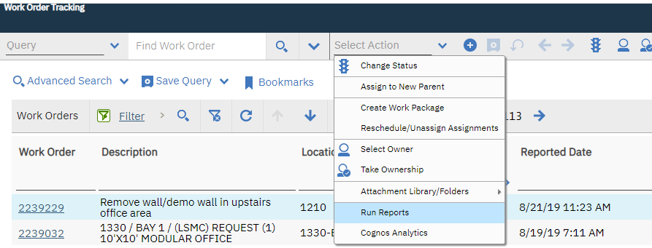
Figure 16-1: Running Standard Reports

- Step 5: First, notice that there are numerous available reports if the user filters or uses the search bar. The user has access to both standard USMCmax reports (either delivered ‘out-of-the- box’ or customized) and QBRs that they created using the Create Report selection or that were made public by another User.
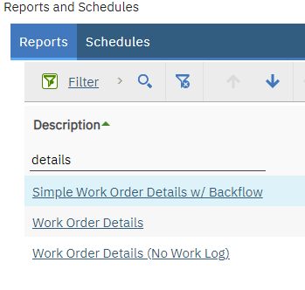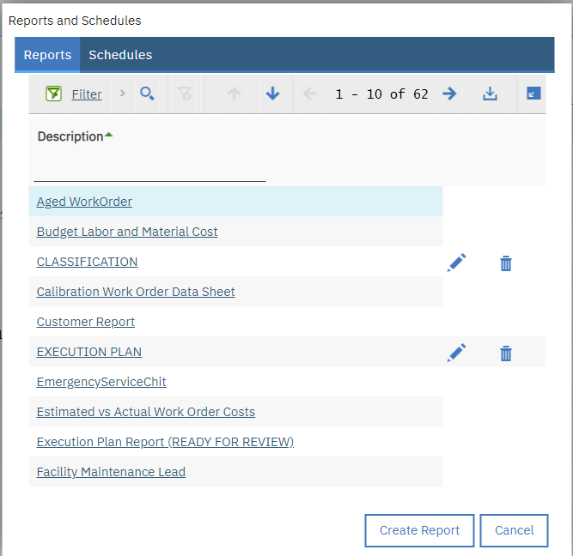
Figure 16-2: Example of Filtering Figure 16-3: Creating QBR Reports

- Step 6: Also, note that USMCmax defaults to the On Demand Reports tab. These reports when selected will be accessed immediately. The User could also click on the Scheduling Status tab and view reports scheduled to run at a specified time.

- Step 7: Example: Type ‘Work Order Details’ in the Search bar, initiate the search by clicking the magnifying glass, and a select a search result to navigate to this report. Click the report to select it.
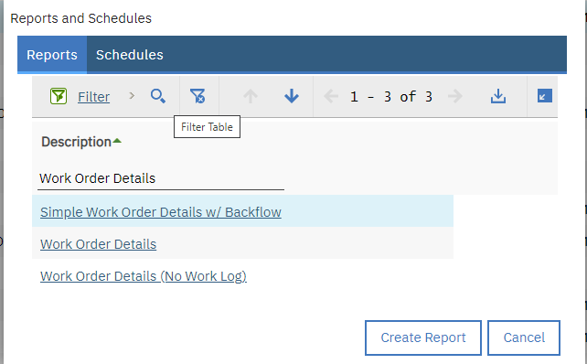
Figure 16-4: Work Order Details Report

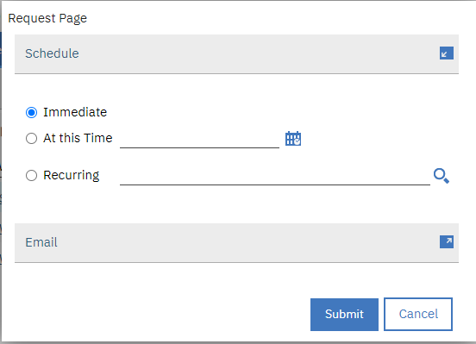
Figure 16-5: Standard Reports - Request Page

- Step 8: Click on the Submit button on the Request Page window.

- Step 9: Give the report a moment to generate; it will pull up in a separate window.

- Step 10: Click on the Export Data tool button on the report.
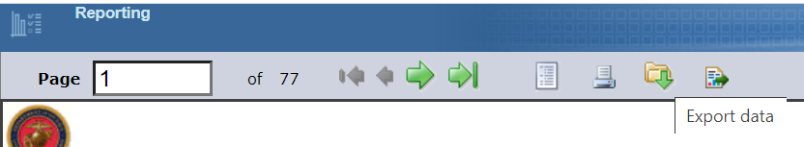
Figure 16-6: Export Data Toolbar

- Step 11: From the Export Data window, the User is able to select specific fields from the report to export. The data from the report will be exported in a CSV format. Click OK.

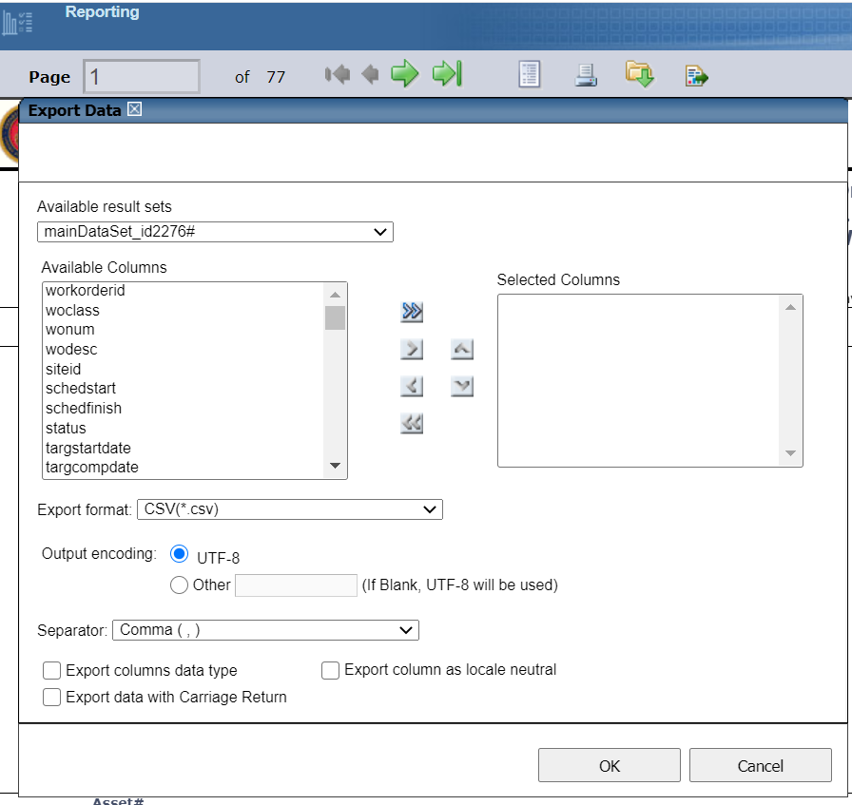
Figure 16-7: Exporting Data from Reports to Excel

- Step 12: Click on the Export Report tool button on the report screen.
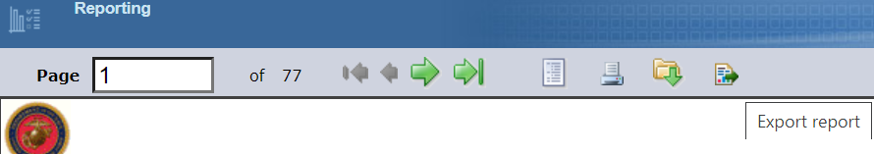
Figure 16-8: Export Report Toolbar

- Step 13: From the Export Report window, the User is able to export the report into many formats including ‘.ppt’, ‘.pdf’, and ‘.doc’ formats. In addition, specific pages can be exported as opposed to the entire report.
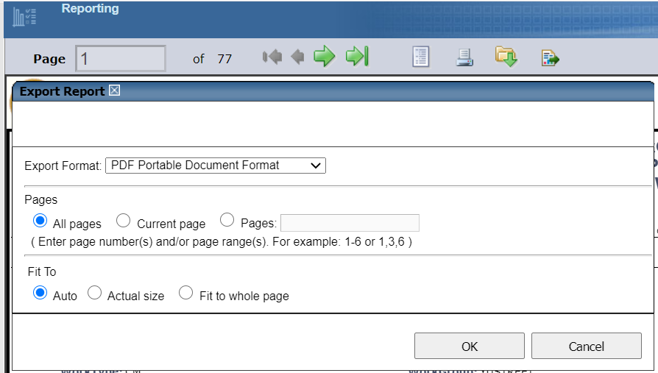
Figure 16-9: Exporting a Report

Scheduling a Report
Scheduling a report allows for records to be stored at standard time.

- Step 1: Select the Report again through the Select Action menu. Based on security permissions, some users may not have this capability.
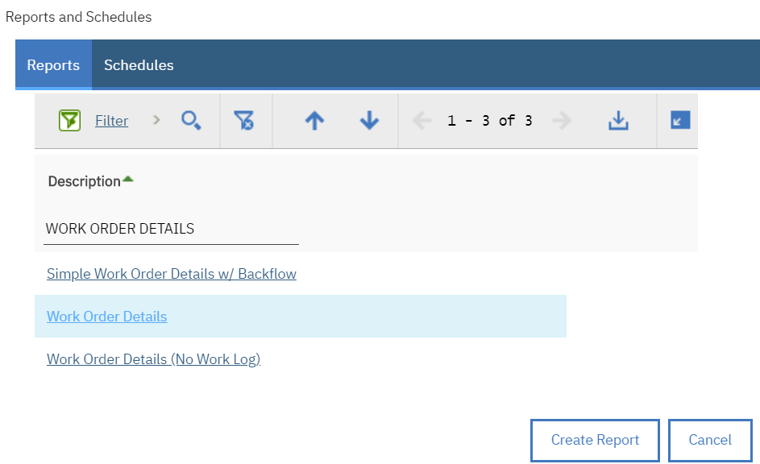
Figure 16.1-1: Selecting a Report

- Step 2: From the Request Page, a report can be run, at a particular time, or on a recurring basis. Select Recurring, type in an email address for the report to send to, the type of report (.pdf or .xls) and click on the magnifying glass icon next to the ‘Recurring’ field.
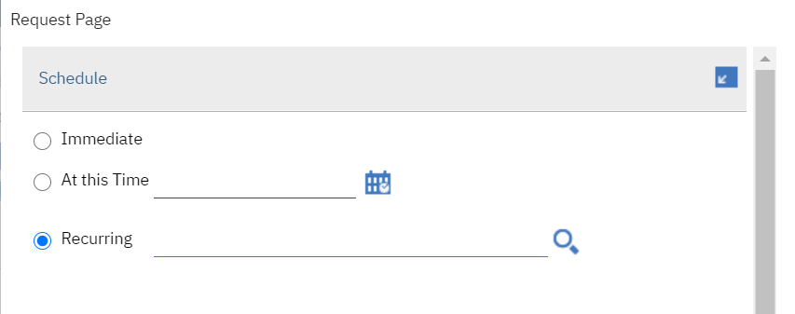
Figure 16.1-2: Scheduling a Recurring Report

- Step 3: Click OK.
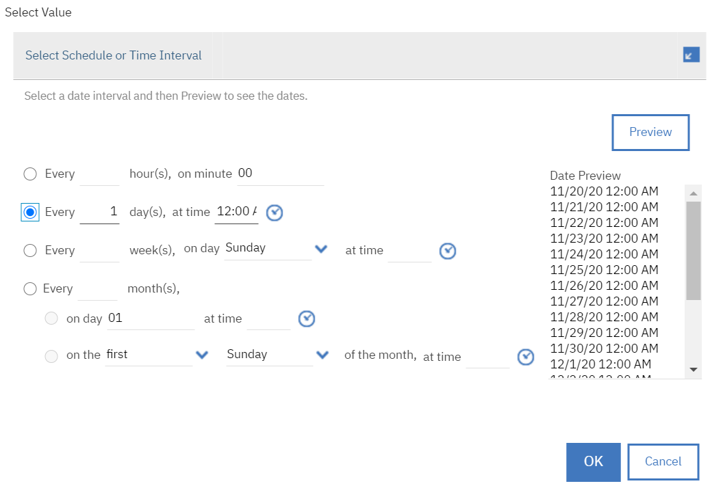
Figure 16.2-3: Scheduling a Time for a Recurring Report

- Step 4: From the displayed Select Value window, set the time at which you would like the report to be emailed to the email address you placed on the request page.
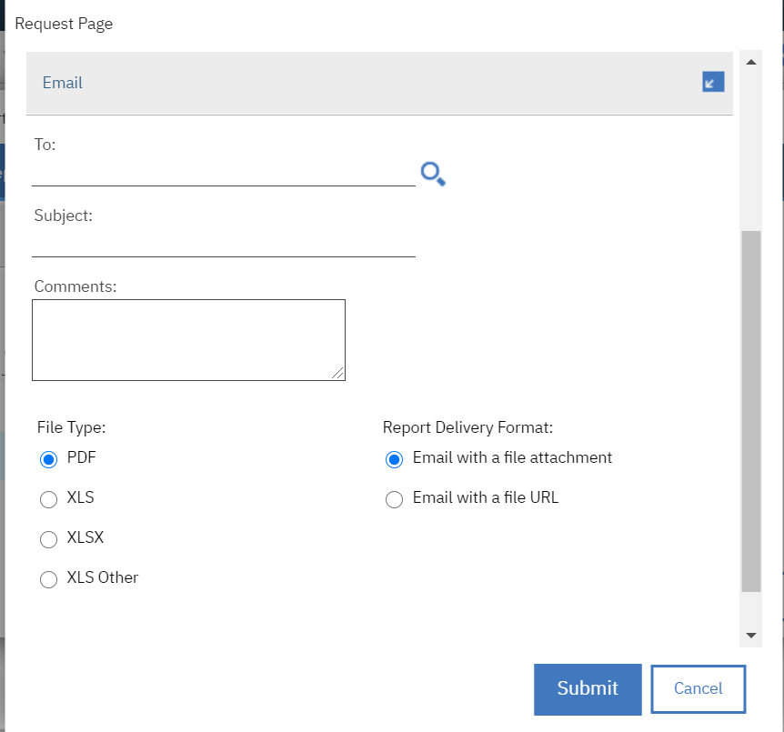
Figure 16.2-4: Emailing a Recurring Report

- Step 5: Click on Submit on the Request page.

To view Scheduled reports, the user should return to the main Reports window and access the Scheduling Status tab. From the Scheduling Status tab, the user is able to modify schedules for reports or delete scheduled reports.

APPENDIX A: Auto SAAR Guide

APPENDIX B: User Overview and Application Information

APPENDIX C: Person, User and Labor Records

APPENDIX D: Locations

APPENDIX E: Recurring Work and Workflow

APPENDIX F: Work Order Tracking

APPENDIX G: Service Requests

APPENDIX H: Acronyms and Definitions
The following table identifies acronyms used throughout the document, and the definition.

Acronym | Definition
APPR | Approved
AutoSAAR | Automatic System Authorization Access Request
BEA | Budget Execution Activities
BESA | Budget Execution Sub-Activities
BMAR | Backlog Maintenance and Repair
BSM1 | Sustainment, Restoration and Modernization
BSS1 | Base Operating Support
CAC | Cost Account Code
COMP | Completed
COR | Contracting Officer Representatives
CSR | Customer Service Representative
CWE | Current Working Estimate
DoD | Department of Defense
FAC | Facility Analysis Code
GL | General Ledger
IA | Information Assurance
ISC | Installation Support Coordinator
IT | Information Technology
ITCR | Information Technology Change Request
LRMP | Long Range Maintenance Plan
MCEN | Marine Corps Enterprise Network
MCICOM | Marine Corps Installations Command
MDI | Mission Dependency Index
MEP | Mission Execution Plan
PAR | Performance Assurance Evaluators
PM | Preventive Maintenance
PO | Purchase Order
POC | Point of Contact
PR | Purchase Request
PURC | Purchase
PWD | Public Works Departments
QA | Quality Assurance
QBR | Query-Based Report
QC | Quality Control
SAAR | System Authorization Access Request
SABRS | Standard Accounting, Budgeting, and Reporting System
SCR | System Change Requests
SDR | Service Desk Request
SLDCADA | Labor Data Collection and Distribution Application
SOW | Scope of Work
UIC | Unit Identification Code
WAPPR | Waiting Approval
WNP | Work Not Performed
WO | Work Orders

APPENDIX I: USMCmax Installation Codes
The following table identifies the Installation Abbreviation Code in USMCmax.

Code | Installation
AL | MCLB Albany
BA | MCLB Barstow
BE | MCAS Beaufort
BP | MCMWTC Bridgeport
CP | MCAS Cherry Point
EI | Marine Barracks Washington, Eighth and I
HI | MCB Hawaii
IW | MCAS Iwakuni
LE | MCB Camp Lejeune / MCAS New River
MI | MCAS Miramar
MU | Camp Mujuk
OK | Okinawa, Japan (All Bases)
PA | MCAS Camp Pendleton
PE | MCB Camp Pendleton
PI | MCRD Parris Island
QU | MCB/MCAF Quantico
SD | MCRD San Diego
TP | MCAGTC Twentynine Palms
YU | MCAS Yuma

